**RGM Govt. Arts & Science College, Attappa**

**Women cell Activities Report 2021-2022**

Women Cell (WDC) of the college is functioning to protect and safeguard the women’ rights. The Cell has both the faculty and students of the College as its members and works with an aim to create and facilitating Women Empowerment through Awareness programmes, Guest talks, and other welfare activities for the betterment of student’s community. Further the Cell is designed to empower women socially, economically strong in society, elimination of violence against women andworks to promote gender sensitivity in the college and to educate the students through different programmes

**Activities for the year 2021-2022**

**Programme1: Awareness programme on Women’s Rights**

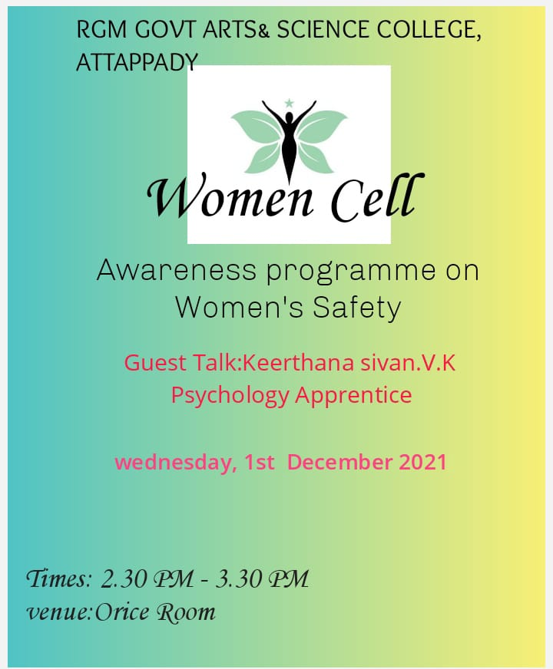

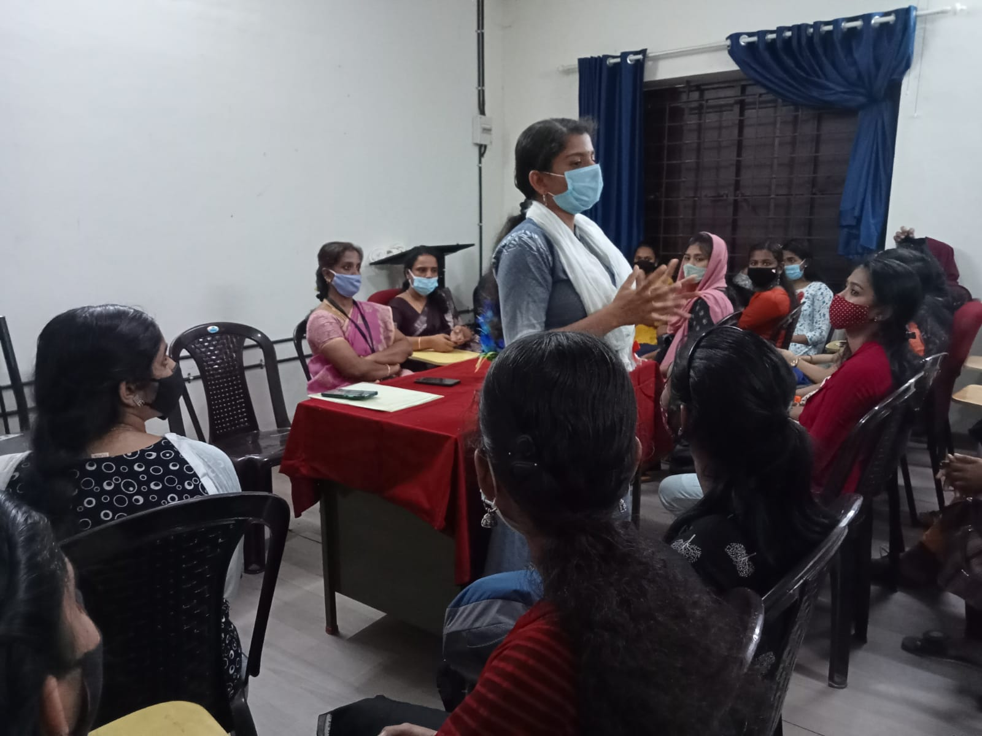

**Awareness programme on Women’s Rights**

**”1st December 2021**

**REPORT**

The Women Cell, Rajiv Gandhi Memorial Govt. Arts & Science College,

Attappadi had organized Awareness programme on Women’s Rights held on 1ST

December 2021.

The session started with a prayer song followed by the welcome address of Women Cell coordinator **MS.K.R.MALARCHITRA** Head & Assistant Prof. in Commerce Department RGM Govt. Arts & Science College, Attappadi, The session continued with the Guest talk by **Ms.Keerthana Sivan V.K,** Psychology Apprentice**,** RGM Govt. Arts & Science College, Attappadi. The Participants of the session is from the Girls Students staying in outside hostels and individual Rooms.

As the session was focused on issues commonly associated with notions of women's rights include the right to bodily integrity and autonomy, to be free from sexual violence, Women's safety involves strategies, practices and policies which aim to reduce gender-based violence (or violence against women), including women's fear of crime. Women's safety involves safe spaces.

Many students were actively participated and shared their knowledge on the same and clarified their doubts with Resource Person. Totally 65 Students were participated in this Session .The session ends with felicitation by Ms.Simi Vincent(Assistant Professor,Sociology),Asha T.Rajan (Assistant Professor,public Admini),Ms.Preethamol(Assistant Professor,Malayalam). The last session was followed Vote of thanks by Priyanka Sapho,Student Join Secretary.

**Programme2:** Guest lecture on women empowerment

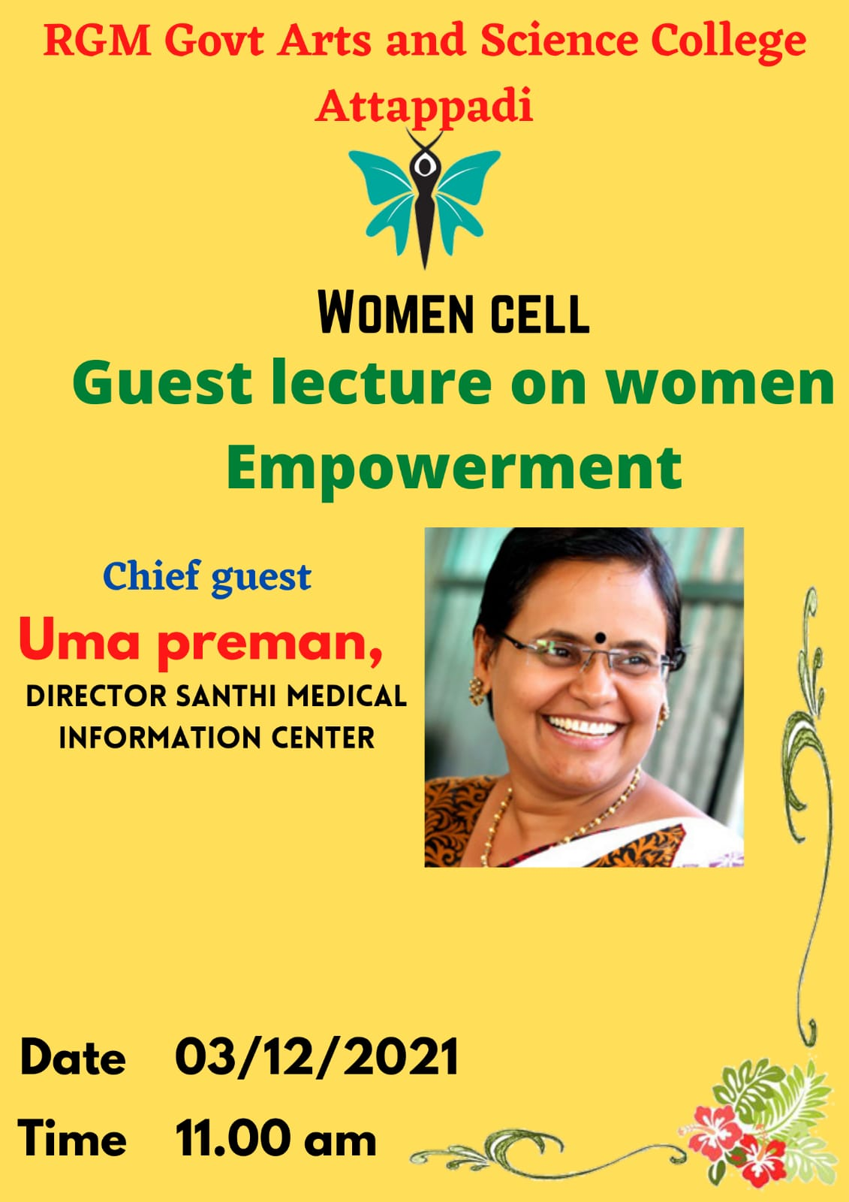

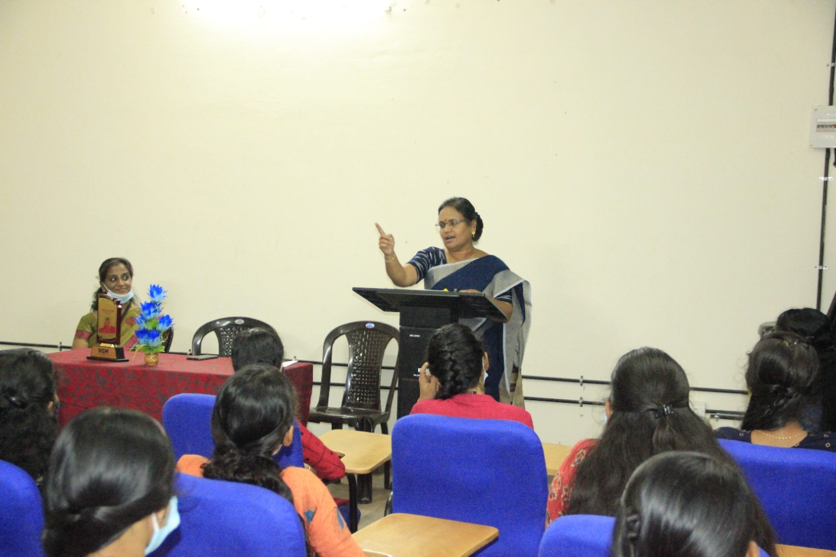

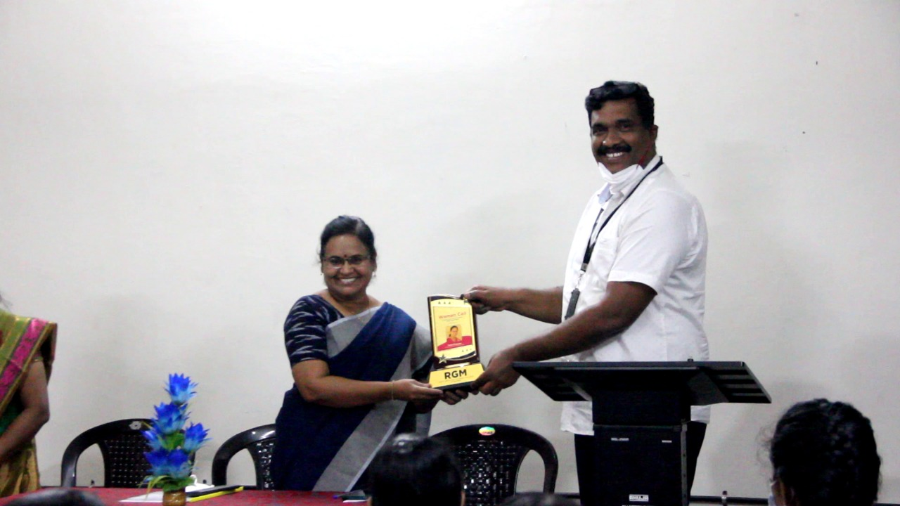

**Guest lecture on women empowerment**

**3rd December 2021**

**REPORT**

The Women Cell, Rajiv Gandhi Memorial Govt. Arts & Science College,

Attappadi had organized Guestlecture on women empowermentheld on 3rd December 2021. The session started with a prayer song followed by the welcome address of Women Cell coordinator **MS.K.R.MALARCHITRA** Head & Assistant Prof. in Commerce Department RGM Govt. Arts & Science College, Attappadi, and presidential address by Dr.Prasad.M.G,Principal incharge.The session continued with the Guest talk by **Mrs.Uma premen,** Director, Santhi Medical Information Centre delivered a session in related with women empowerment consist of women’s present status in society, Gender issues, Employment status, protection and safeguard of women’s against violence. The students were actively participated and shared their knowledge on the same and clarified their doubts with Resource Person..The session ends with felicitation by Ms.Simi Vincent(Assistant Professor,Sociology), Ms.Preethamol(Assistant Professor,Malayalam). The last session was followed Vote of thanks by Priyanka Sapho,Student Join Secretary.

**Programme 3: Counseling to Hostel Students staying in outside Hostel**

**Date: 12th JANUARY 2022**

**REPORT**

The Women Cell, Rajiv Gandhi Memorial Govt. Arts & Science College, Attappadi had organized a session on counseling to Hostel Students held on 12th January 2022. The session started with a prayer song followed by the welcome address of Women Cell student secretary Priyanka sapho, followed by the session handled by K.R.Malarchitra, Assistant Professor of commerce.

More than 90 students are participating in this programme they are staying in outside Hostel in around Attappady. Counseling is given to the students regarding

Safety measures, protection against Women Violence and other welfare measures needed for the protecting Girls.

**Programme 4 : Guest talk on women's Rights**

**Date : 8th March 2022**



**REPORT**

RGM Govt arts and Science college, Attappady ,women cell organized women's day celebration talk on 8th march 2022 at 10.00 am women's Rights by chief guest Ms.Bincy, Advocate, Welcome address K.R Malarchitra, Women cell coordinator Assistant professor, RGM college,Presidential address by Dr.prasad.M.G,principal,the session was very useful the guest explained the various laws and sections relating to women’s rights.

